Teacher Education Policy Brief
Who are we referring to?
What is at stake? What are the challenges?
Why a focus on Teacher Education?
What we are trying to achieve:
Situation Analysis
Quality Framework
Appendices
1 Stakeholder perceptions from workshop
2 National Education Strategy 2017- 2027, highlights
3 National Commitments to Transforming Education highlights
4 EMIS, Census Data 2021

Who are we referring to?
This teacher education policy is directed to support the professionalisation of ‘all those persons in schools or other learning sites who are responsible for the education of children or young people in pre-primary, primary, lower secondary and upper secondary education. It equally covers teachers in both public and private institutions (including non-governmental organizations) and school heads, directors or principals and deputies as part of school leadership and governance.’
This policy is intended to shape both in-service and pre-service teacher education.

What is at stake? What are the challenges?
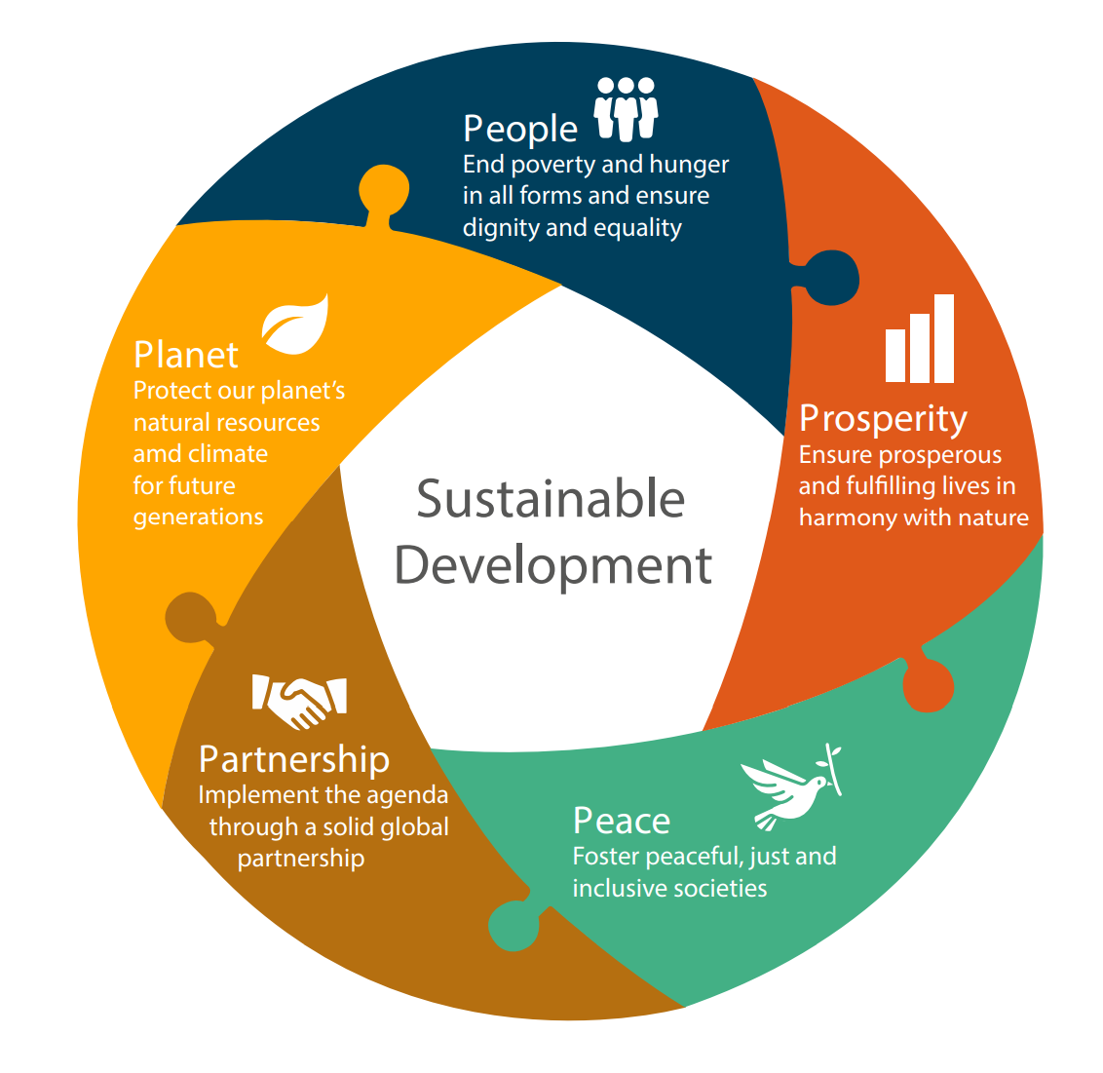
The model above represents the 5 Pillars of Sustainability as presented in the 2030 Sustainable Development Goals. Using this model in the South Sudan context, raises the following challenges:
People and Prosperity. Illiteracy levels are limiting progress. The World Population Review lists South Sudan to be one of the most illiterate countries in the world and UNICEF (2019) states that more than 2.8 million children, over 70%, are out of school. The largest group of out-of-school children in South Sudan are girls, with poverty and child marriage being a significant contributor to this.
People. Poverty: 91.9% of the population in South Sudan is multidimensionally poor. Some two-thirds of its total population of 11.4 million were estimated to be in need of humanitarian assistance in 2022.
Planet. Environmental instability: South Sudan is highly prone and vulnerable to climate-related shocks, which have a devastating impact on people’s welfare. Since 2011 alone, it has suffered severe droughts and floods. The May-November 2021 floods, reportedly the most devastating since the early 1960s, affected 9 out of 10 states, impacting around one million people and displacing more than 300,000.
Peace. Insecurity still persists in communities across the country.
Partnership. At present, a lack of coordination between stakeholders in education results in efforts having less impact than they should.

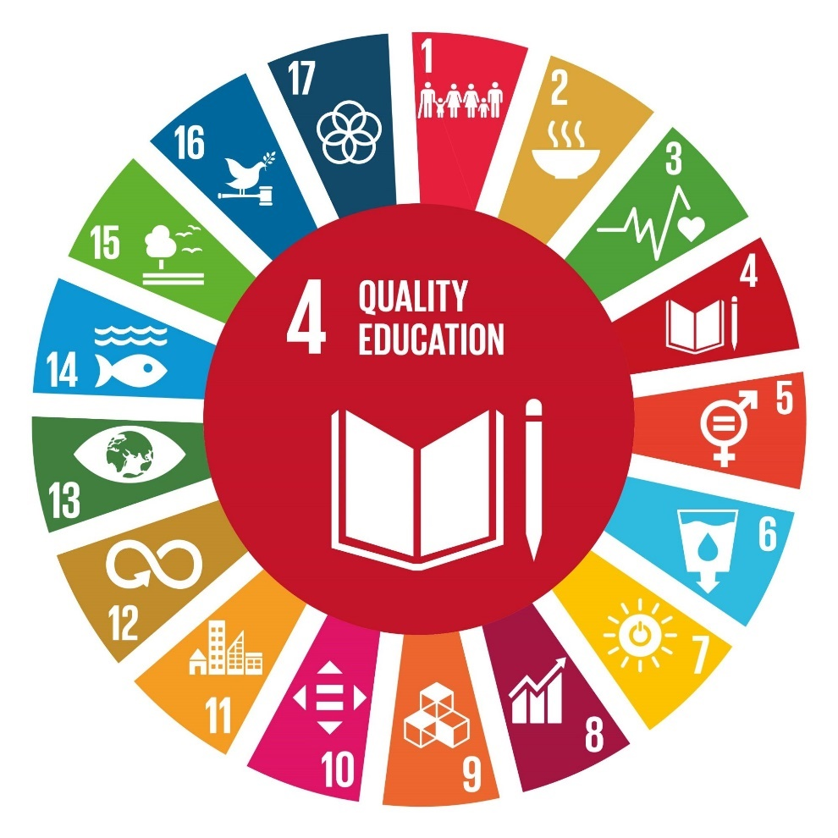
The contribution that Education can make to addressing these challenges is represented in this related circular graphic illustrating the value and impact of Quality Education. Improving the quality of education will result in improved capacities to address inequality and instability in the remaining Sustainable Development Goals.

Why a focus on Teacher Education?
There is a growing recognition that the quality of teaching is central to the improvement of learning outcomes for children and young people (Timperley, 2008).
Moon (2013) explains that improving teacher quality contributes to efforts towards the alleviation of poverty. In addition, Hanushek & Rivkin (2012) present data that demonstrates a firm correlation between average student learning levels and long-term economic growth and peace.
A system that produces and monitors the teacher workforce is vital.
Preliminary findings from the Sector Analysis presented to stakeholder in January 2023 highlighted:
“…a shortage of teachers and the quality of primary education in South Sudan's biggest challenge.”

What we are trying to achieve:
To strengthen the teacher education system to improve the quality of teaching, accelerating the effectiveness of the workforce.
To enable children to achieve the outcomes of the curriculum through improvements to the quality of workforce.
The outcomes of the South Sudan curriculum are intended to support the development of literate and responsible citizens, capable of establishing and maintaining peace to drive prosperity, growth and development, harmony and justice for all.
Improving the quality of teaching will improve the likelihood of learners achieving the aims of the curriculum.

Aims of the curriculum:
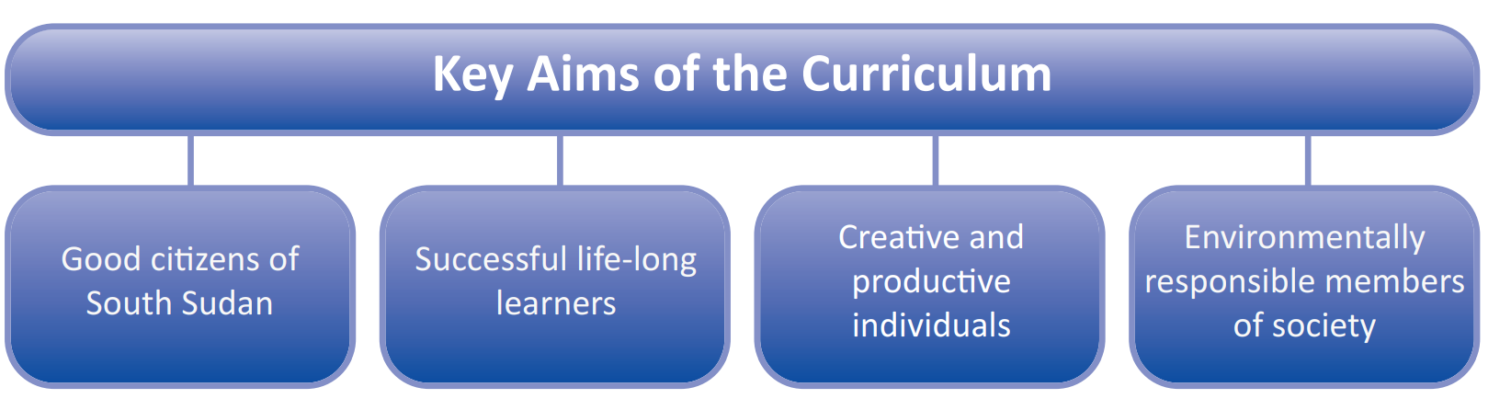

The Education Act 2012 describes goals which rely heavily on an effective teaching workforce also:
The education system in the Republic of South Sudan shall be directed towards meeting the following goals:
a) Eradicate illiteracy, improve employability of young people and adults and promote lifelong learning for all citizens;
b) Provide equitable access to learning opportunities for all citizens to redress the past inequalities in education provision;
c) Achieve equity and promote gender equality and the advancement of the status of women;
d) Contribute to the personal development of each learner and to the moral, social, cultural, political and economic development of the nation;
e) Promote national unity and cohesion;
f) Enhance the quality of education and encourage a culture of innovation and continuous school improvement and effectiveness; and
g) Develop and promote a general scientific approach in education. General Education Act, 2012
Situation Analysis
In preparation for the development of a National Teacher Education Policy for South Sudan, a situation analysis has been conducted in order to enable key priority areas to emerge. The following analytical activities have taken place between July 2022 and February 2023:
Review of International Frameworks
Review of South Sudanese Documents
Literature Review
Interviews with teachers across South Sudan
Interviews NGO Education Leaders
Multi-Stakeholder workshop

International Frameworks
The following international Frameworks have been reviewed and have contributed to being able to identify Priority Areas for Development:
Human Rights Act 1998 and The United Nations Convention on the Rights of the Child
Child Friendly School Framework
Teacher Education Taskforce
INEE Minimum Standards
Teacher Policy Development Guide, UNESCO

South Sudanese Document analysis
The following official South Sudanese documents have been reviewed to ensure that legislative frameworks are considered in the development of the teaching workforce.
South Sudan Vision 2040
Education Act 2012
National General Education Policy, 2017-2027
South Sudan Transforming Education National Committments
EMIS 2021 Education Census Report
National Professional Standards for Teachers
Out of Schools Children Report 2019; 2021
Pre-Service Pre-Primary and Primary Certificate and Diploma Syllabus
School Inspection Policy
South Sudan Vision 2040:
‘TOWARDS FREEDOM, EQUALITY, JUSTICE, PEACE AND PROSPERITY FOR ALL.’
This vision lists Goal number 1 as building an education an informed nation. Rather like the sustainable development goal circular image above, it can be said that if Goal 1 is achieved, then the rest of these goals are made possible also.
Strategic Goal (1): To build an educated and informed nation.
Strategic Goal (2): To build a prosperous, productive and innovative nation.
Strategic Goal (3): To build a compassionate and tolerant nation.
Strategic Goal (4): To build a free, just and peaceful nation.
Strategic Goal (5): To build a democratic and accountable nation.
Strategic Goal (6): To build a safe, secure and healthy nation.
Strategic Goal (7): To build a united and proud nation.

Education Act 2012
In addition to the points listed in the introduction to this brief, the following points also demonstrate a commitment to the Training and Development of Teachers:
25:
(A) The Ministry of Education shall develop a policy of teachers’ training and development to cover both pre- and in-service teachers’ training to be implemented by all the State Ministries of Education and other institutions throughout the country.
(B) The Ministry shall ensure that the policy of teachers’ training and development is implemented consistently throughout the country.
(C) The Ministry shall also develop national professional standards for teachers to be used as the basis for teachers’ training and development programs in the Republic of South Sudan.
(D) The Ministry shall develop teachers’ training and development programmes based on the national professional standards for teachers.
Important to note in these statements are the reference to the Professional National Standards for Teachers and a call for a consistency of standards in teacher training across the country.

National General Education Strategy, 2017-2027
Of significance here is the issue that ther Ministry is committed to implemetig teacher training consistently and that all teacher training is based on the Natioal Professional Standards for Teachers. The Strategy states that it aims to support the development of motivated teachers who are committed to buildingt their professionalism. The strategy is clear about the need to build the capacities of NTTIs and to decentralise training systems to included CECs also.
See Appendix 2
South Sudan Trasforming Education National Committments
Of significance here is the intention to ensure that all techers meet the minimum standards for recruitment (Secondary School Leavers Certificate) and that more teachers need to be recruited to meet the shortage of teachers. It is important however to note, that recruitment through NTTIs and Universities currently stands very low but that there are a large number of teachers who have considerable in-service experience who with need-based support could achieve minimum standards or indeed gain QTS through CPD courses.
See Appendix 3

EMIS 2021 Census Report
Of significance here is that the number of female teachers is only around 17% of the workforce. It is vital to address this imbalance, recognising that the number of girls who complete secondary school is lower than that of their male counterparts and also that they are more likely to drop out of Primary Schools than the boys. The Census Report also shows that more than half of the workforce have no qualifications.
See Appendix 4

National Professioanl Standards for Teachers
These standards describe expectations for effective teachers in South Sudan. The term ‘teacher’ as used in this document means ‘effective teacher’ inclusive of the seven domains of the professional standards.
The standards are not intended to show isolated knowledge or skills and are not presented in order of importance.
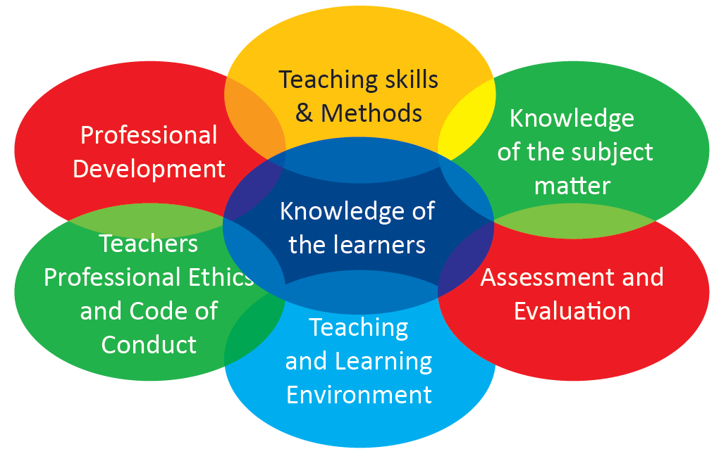
Teacher’s knowledge, understanding, attitudes and skills in each standard area will impact on their ability to perform effectively in the other standard areas.
Each of these standards is important for effective teaching. Of significance here is the interrelated aspect. Too often, our analysis has shown that aspects of professionalism are dealt with individually. The pre-service syllabus attempts to address the need for integration.

Out of Schools Children Report (OOSC) 2019, 2021.
The 2021 Report, highlighted issues include the need for teachers to be adequately trained to facilitate learning in inclusive learning spaces. OOSC are typically multidimensionally vulnerable and therefore effective re-integration into learning necessitates teachers and school leaders to be equipped with skills to be able to provide psycho-social support and be adept at engagement with multisectoral actors to ensure relevant support to vulnerable children. These efforts will contribute to retention and progression of disadvantaged learners. Recommendation 18 and 19 confirms a need for the professional development of teachers to address the demands of communities where OOSC is particularly high, strengthening existing initiatives and incorporating action research to better understand what is needed the most.
Pre-Service Pre-Primary and Primary Certificate and Diploma Syllabus
Grounded on the Professional Standards for Teachers in South Sudan and the SS school curriculum, pre-service certificate and diploma teacher training syllabi have been designed to equip ECE and primary teachers with knowledge and skills to deliver a competency-based curriculum. Areas of learning are:
It is important to note here that the study of learning theories and inclusive practices are to be explored alongside curriculum expectations and the role of the teacher. This blend of learning for ITT is an important principle of design for TPD.

National, Part-time CPD In-Service Programme leading to Qualified Teacher Status (QTS)
An In-service (CPD) programme has been developed that will enable unqualified ECD and Primary teachers to obtain Qualified Teacher Status. This is based on the pre-service syllabus and is designed to be delivered in 8, 1-week courses over 2 years with continuous support for teacher and assessment through a Portfolio of practice.

School Inspection Policy
The principle that teachers are accountable for their performance and the quality of their teaching is key to a high-status teaching profession and to enhancing learning. There is a reciprocal principle that education systems should be accountable to teachers, providing effective support and acceptable working conditions. The new School Inspection Framework and related revised Policy clearly outlines this accountability principle of quality education.

There are seven areas on which inspectors focus upon during an inspection. These cover those aspects of a school that impacts on the quality of education that is provided, and the health, safety and security of learners and teachers. The framework incorporates the six key features of child friendly schools:

- Rights-based: remembering that children’ rights are also human rights.
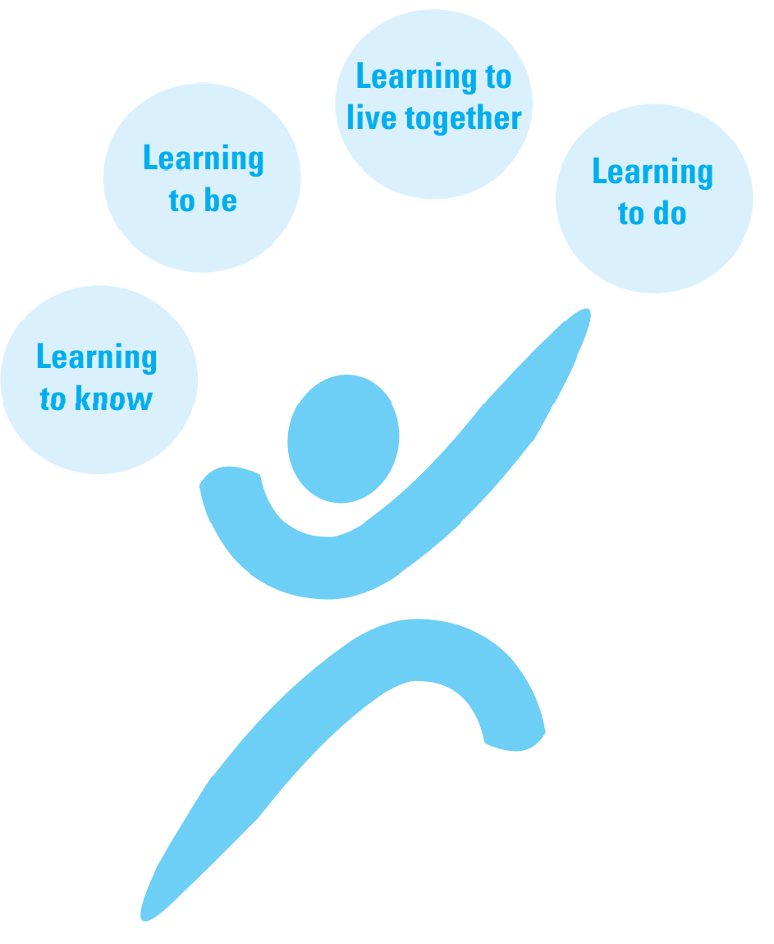
- Effectiveness: achieved where teachers are consistently present and girls and boys achieve
meaningful learning outcomes.
- Equity and equality: a CFS promotes equity and equality, especially gender equality.
- A protective environment: a CFS shelters and protects its learners, providing them with a safe space in which to learn, grow and develop.
- Health promoting and health seeking: a CFS is a ‘talking school’ that communicates important messages to learners, teachers and the surrounding community. Not least of these concerns health related knowledge and life skills. The CFS is a vibrant centre for dialogue, enabling learning to take place through interactions between teachers, learners, parents/ carers and members of the community.
- Active community partnerships: a CFS school establishes a special working relationship with the community in which it is located and with the parents of the girls and boys attending the school.

Building upon these 6 CFS features, the seven focus areas of the inspection are as follows:
- Curriculum
- Attainment and Progress
- Teaching and Learning
- Care and Conduct of Learners
- Community Relationships
- Leadership and Management
- Facilities

Literature Review
The purpose of this literature review is to contextualise the findings of the documentation review and the surveys of teachers, school leaders and other stakeholders. This is a thematic review of relevant literature, drawn, as far as possible from the context of education in Sub-Saharan Africa. It identifies key issues relating to continuing teacher education, offering insights into the design of effective continuing professional development (CPD) courses.
Recommendations drawn from this analysis of the literature draw closely upon the findings of Popova, et al. (2018) and Badroodien (2018. Continuous Professional Development should not only develop teacher skills and knowledge of pedagogical theories but also challenges within the context of specific subjects in the school curriculum. should be focused particularly on newer teachers (within the first five years of their career) and, wherever possible, build on the themes set out in the content of the Pre-Service, Initial Teacher Training syllabus. CPD should not be designed or delivered as one-off event but as part of a process of ongoing implementation and reflection with dialogue between the trainee, colleagues and mentors. Trained school-based mentors can support CPD within a structured framework of reflection and ongoing support.
It is critical for CPD to be a co-ordinated effort between stakeholders to limit repetition and build on successes. Training for teachers should include dedicated, systematic approaches to monitoring and evaluation, ensuring that CPD is continually assessed so that it has the desired impact on learning. Continuous Professional Development (CPD) should be linked to career progression
A teacher policy should strive to establish a working (teaching/learning) environment conducive to motivating individual teachers and the school team to achieve three simultaneous and interacting goals:
- produce the highest levels of professional teaching and job satisfaction;
- focus on core teaching and learning responsibilities;
- maximize teacher effectiveness, as measured by learning achievements or outcomes.
References Appendix 5

Interviews with teachers
Key themes that developed from interviews with teachers included a strong sense of teachers feeling proud of what they do. Many teachers talked about their commitment to enabling the ‘next generation’ to shape the country for the better. Teachers talked about how much they feel valued and respected by their communities but that working conditions made it a challenging role. Not many teachers talked about professionalism or feeling part of a community of educators although some teachers commented that other teachers in their school were who they turned to for help with teaching. Teachers said that they felt proud when they saw their students out in the community doing important jobs but that also, the behaviour of children was challenging at times also. The following is a list of key ideas that teachers suggested people coming into the profession should know:
- Teaching is ‘not for men only. We have the same brain. What a man can do, a woman can’
- Ignore negative perceptions of being a teacher
- ‘teaching is a national duty’
- Teacher can ‘bring South Sudan together’
- Don’t give up, even if life is hard ‘suffer to achieve dream’
- Help shape our communities
- Have the passion of being a teacher
- ‘Sacrifice yourself to teach our pupils’ (for) ‘our beloved country’ – to change country.
- Makes you ‘a good person in life’
- Teaching can ‘develop community’, ‘benefit society’ and ‘develop country’
- Keep teaching to develop knowledge
- Come to be a teacher; improve education in South Sudan

Interviews with NGOs
Education leaders of NGOs in South Sudan told us that there are the following themes that need to be addressed to improve the quality of teacher education:
1) The Status of teachers, including qualification, retention and recruitment, salary and motivation.
2) Models of support for teachers from NGOs, including content, structures and certification.
3) Monitoring and evaluation of CPD, including follow-up activities, needs analyses and reporting.
4) The role of the Head Teacher including school-based and external support.
5) National structures and strategies for Teacher Education including alignment, coherence, capacity and monitoring.
6) Impact of covid-19 on CPD including the effects on the workforce and communities.

Perspectives from Stakeholder workshop January 2023
The stakeholders workshop brought together representatives of all MOGEI directorates, teacher training institutions (Juba and Upper Nile Universities as well as National Teacher Training Institutes (NTTIs)), as well as NGO partners involved in teacher training, secondary and primary school teachers and learners. The key perspectives elicited from this group were that teachers need to be adequately trained to effectively deliver the new curriculum. Professionalisation of teachers and school leaders would greatly enhance school governance and learning. Initial teacher training (pre-service) and Continuous Professional Development (in-service) must be standardized and grounded on the National Professional Standards for Teachers, the aims of the South Sudan curriculum and systematised for accreditation. Principles of equity and inclusion will guide enrolment priorities specially to push female enrolments and to ensure language proficiency of teachers in line with the national policy.
See table Appendix 1
A Quality Framework for Teacher Education
A Policy for continuous improvement
A policy for teacher education in South Sudan should continue to be a co-created document that seeks the views and voices of a range of stakeholders, prioritising the voices of teachers.
The 4 R's Framework (Novelli et al., 2014) has been used already to examine educational governance and policy in relation to education, conflict and peace in South Sudan. This Policy aims to build on that work, recognising that each of the 4 R's has a role to play in ensuring the development of an effective, aspirational and viable Teacher Education Policy for South Sudan:
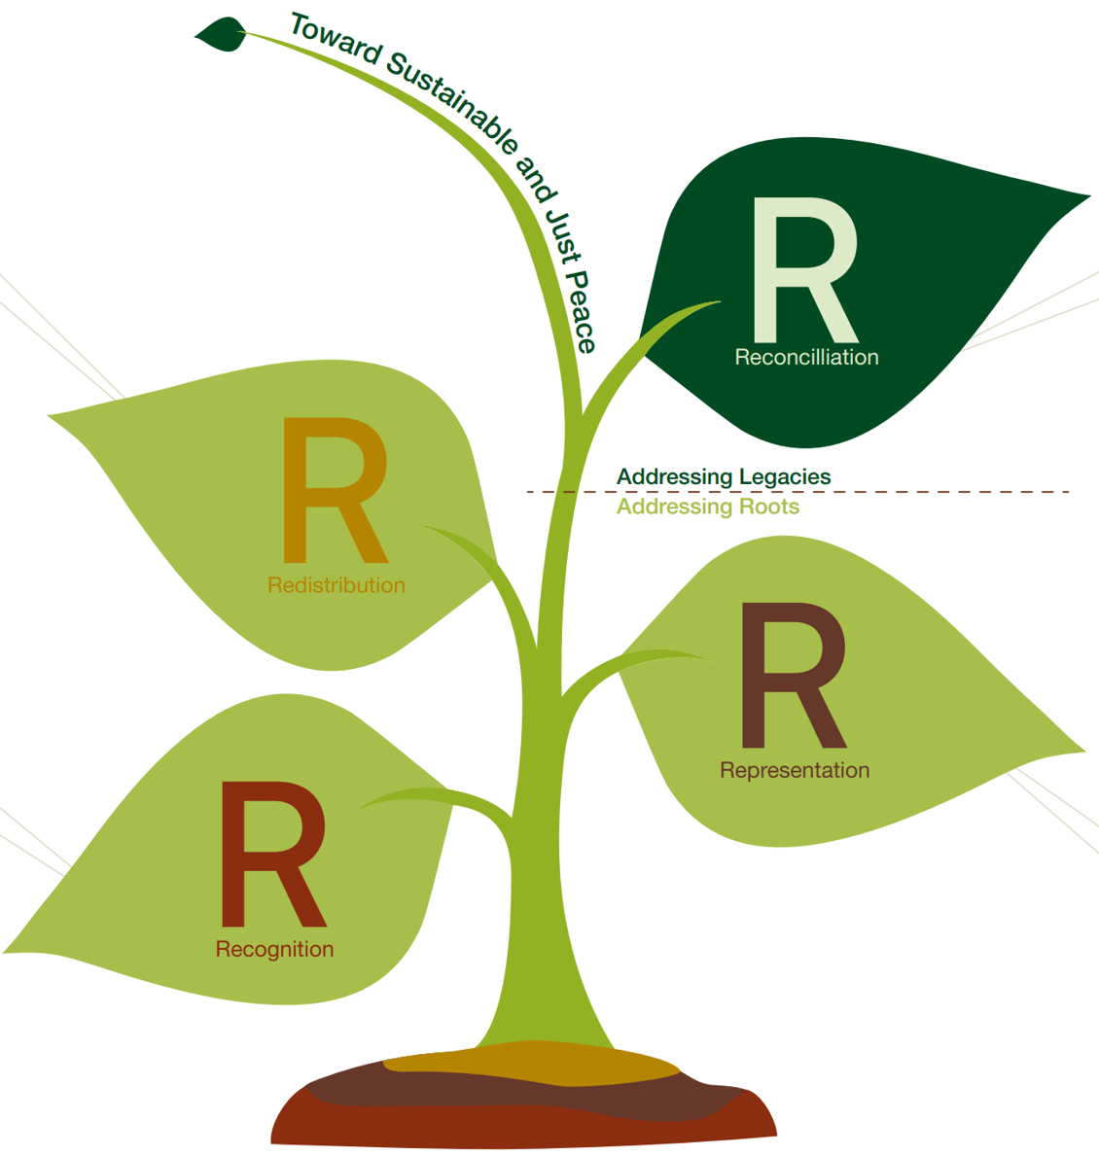

Redistribution (addressing inequalities);

Recognition (respecting difference);

Representation (ensuring participation);

Reconciliation (dealing with the legacies of the conflict).

The policy will be informed by the values and principles that support the curriculum for schools:
Values of:
- Respect and integrity
- Peace and tolerance
- Human rights and gender equity
- Compassion and social justice
- Democracy and national pride
Principles of:
- A culture of excellence that supports innovation, creativity, continuous improvement and effectiveness
- An environment of empowerment that promotes independence, individual learning, critical thinking,
- Problem solving and emotional intelligence
- A context of South Sudanese heritage and culture that builds national pride and identity within an understanding of global citizenship
- A spirit of hope, respect, peace, reconciliation, unity and national pride, democracy and global understanding

Based on the situation analysis, the following Priory Areas have been identified as needing particular attention and development within strategies to improve and sustain the education workforce:

- More qualified teachers
- More female teachers
- Strengthen systems for teacher training (NTTIs, faculty of education, CECs)
- Tiered pre-service training aligned to the new curriculum: certificate, diploma, degree.
- Inclusive, needs-based CPD
- Co-ordinated efforts to strengthen the workforce
- School leadership
- A clear career structure for teachers - qualification/accreditation and awards for specialisms

Based on all of the above, a Quality Framework has been developed aimed at supporting the government to ensure that all Teacher Education programmes are aligned to the findings of the situation analysis and thus, promote the sustainable development of improvements to the education workforce.

Teacher Education should be underpinned by Values and Principles of:
- Inclusion and equity
- Compassion and social Justice
- Collaboration and co-operation
- Respect and integrity
- Peace and tolerance

Teacher Education programmes should adopt a number or design principles.
Programmes should:
- Support the well-being of teachers
- Acknowledge the multi-faceted circumstances that teachers find themselves within
- Be evidence informed – literature and documents, inspection, field-work.
- Be rigorous with respect to monitoring, evaluation and review cycles
- Provide follow-up and on-going support for teachers
- Be frequent and regular rather than ‘one-off’ in nature
- Commit to developing communities of practice
- Be aligned to the new curriculum
- Be based on the syllabi for the Pre-Service National Certificate, Diploma and Degree courses.
- Be based on professional standards for teachers
- Be anti-corruption
- Promote language development; language of teachers – (Arabic pattern and Mother Tongue should not be seen as a language barrier, but instead an opportunity); Language ECD to P3; Transition year P4; English .

Appendix 1

- Key challenges to improving the quality of ‘teaching’ (stakeholder perceptions)
Level of responsibility | Responsibilities and accountabilities
Government | - Lack of political will to recruit and remunerate teachers reasonably well and regularly (to retain trained teachers)  - Lack of career progression strategies including retirement packages  - Lack of financial and skilled human resources for NTTIs  - Few female teachers  - Low numbers of trained teachers  - Ineffective recruitment strategies  - Lack of schools and teachers’ quarters
Training institutions | - Ineffective admission policies  - NTTIs not adequately supported and equipped to deliver quality teacher education programmes  - Insufficiently trained and experienced NTTI tutors  - Teacher training programmes not meeting acceptable standards (ref Professional Standards for Teachers in SS)  - Ineffective training including delivery of new curriculum, new pedagogies, ICT, inclusive education  - Arabic pattern teachers struggle teaching in English
School & management | - Untrained school leaders  - Lack of conducive teaching and learning environment  - Overcrowded classrooms  - Insufficient supervision/follow-up of learners by teachers and parents  - School stakeholders not supportive to teachers
Self (teacher) | - Incompetent teachers  - Ineffective training/lack of training  - Lack of motivation due to low and irregular remuneration, poor working environment  - Lack of commitment and skills to develop and use of locally relevant LTMs  - Lack of understanding of teacher’s role and responsibility (ref Professional Standards for Teachers in SS)

- Who should be trained to do what and why

WHO | WHAT | WHY
Untrained teachers (school leavers P8, S4, primary & secondary dropouts, degree holders without teaching qualifications)  *S4 completers to train at universities for degree/NTTIs for Diploma  *Sec school dropouts to train at NTTIs - Certificate  *University graduates enrol for PGCE | - Acquire minimum requirements (knowledge, skills and attitudes) for teaching profession (ref Professional Standards for Teachers in SS including code of Conduct)  - Trained to effectively deliver the new curriculum | - Ensure quality teaching and standards in schools  - To contribute to the teaching workforce
Volunteer teachers (school leavers, dropouts, degree holders without teaching qualifications)  *P8 completers train as ECE and lower primary teachers | - Acquire minimum requirements (knowledge, skills and attitudes) for teaching profession (ref Professional Standards for Teachers in SS including code of Conduct)  - Trained to effectively deliver the new curriculum | - To contribute to the teaching workforce  - Ensure quality teaching and standards in schools
Arabic pattern teachers | - Improve English proficiency  - Better delivery of new curriculum | - To improve their use of language of instruction  - To ensure quality teaching and standards in schools
National languages teachers | - Knowledge and skills on language use to facilitate the new curriculum | - To improve their use of language of instruction  - To ensure quality teaching and standards in schools
Qualified teachers | - Trained to effectively deliver the new curriculum  - Trained to provide peer to peer support (mentoring) | - To update teachers’ knowledge, skills and attitudes to be able to deliver new curriculum in inclusive settings  - To effectively mentor newly trained and untrained teachers
School leaders (headteachers) | - Management and leadership  - Ensure core values of the curriculum are upheld  - Supervise and support staff  - Provide orientation of teachers and mentor  - Coordinate school and community through PTA, SMC and BOG | - To ensure quality teaching and standards in schools  - To ensure effective, collaborative and inclusive school governance
NTTI and CEC Tutors | - Knowledge, skills and attitudes to deliver the new curriculum in inclusive classroom settings, making and using locally available LTMs  - Train teachers to effectively facilitate the new curriculum, new pedagogies, ICT and cross-cutting issues  - Support teachers in schools  - Train headteachers on effective school governance | - To ensure quality teaching and standards in schools (ref Professional Standards for Teachers in South Sudan)
School inspectors/supervisors | - Support teachers in schools to gain knowledge and skills in delivery of content  - Coordinate and support in improving schools/institutions  - Supervise school leaders | - To ensure efficiency and effective school management (ref Inspection Framework)  - To ensure quality teaching and standards in schools (ref Professional Standards for Teachers in South Sudan)

- Key elements of the Teacher Education Policy

Key Issues in policy | Elaboration
Entry requirements | Teachers who are  P8 completers take ASEP to obtain for Secondary Certificate.  S4 leavers qualify for entry to NTTIs for Diploma or Certificate courses  Degree holders (non-education courses) can enroll for PGCE  *Entry requirements for females can be slightly lower pass rates (e.g. 5 percentage points) to enhance their enrolment numbers
National professional standards for teachers in SS | The national standards should be reflected in all pre-service and in-service/CPD curricula and training methodologies and in assessment methodologies i.e.  - Knowledge of the learners of how they learn  - Knowledge of the subject being taught  - Teaching methods  - Assessment and evaluation methods  - Learning environment  - Professional responsibility and growth  - Teachers’ code of conduct and professional ethics
Certification and accreditation | - Teacher training uses formative and summative assessment (continuous assessment and examinations); harmonize grading system  - Standardize teaching practice  - Universities accredit all professional Certificates, Diplomas, Degrees  - Offer and award Degrees and Diplomas  - ECD/ECE  - Primary  - Secondary  - NTTIs offer and award Diplomas and Certificates  - ECD/ECE  - Primary  - CECs offer In-Service/CPD  - ECD/ECE  - Primary  - Graduation, Registration and Licensing
Roles of County Education Centres (CEC) | - Identify teachers for further training  - Train teachers – pre- and in-service  - Offer and conduct refresher courses and set conducive learning environment  - Supervise teachers in the payam, county and bomas and monitor progress  - Mentor teachers during teacher training courses  - Coordinate educational matters between the county and state  - Design short-term in-service programmes  - Collaborate with NTTIs  - Prepare LTMs using locally available materials  - Prepare in-service teacher trainees for and supervise them during teaching practice  - Keep records of in-service students  - Distribute school materials and keep records accordingly
Promote female teachers | - Provide scholarships for females to increase the number of trainees  - Provide opportunities to upgrade their qualifications through in-service courses especially those in rural areas  - Ensure gender responsive planning and monitor recruitment, training (including in leadership and school management) to facilitate career mobility (at all administrative levels taking into consideration cultural and religious influences)  - Female teachers act as role models for girls, effectively promote girls education and gender equality
Inclusive education | - All teachers should have basic training on inclusive education, at a minimum and be able to facilitate learning for learners with disabilities in an inclusive learning environment  - Promote accessible schools/learning environments  - Train teachers to provide psycho-social support
Monitoring and evaluation | - Monitoring and evaluation framework should be designed to monitor the teaching force quality of education at all administrative levels  - Effective inspection system is an important part of M&E  - Participatory M&E by stakeholders
Promotion of Languages of Instruction | - Train primary school teachers to facilitate learning in National Languages from ECD to P3 and then transition to English as Language of Instruction
Roles and responsibilities of stakeholders | - National MoGEI:  - develop TE policy, disseminate, support and monitor its implementation; mobilize resources for its successful implementation; advocate for resourcing of NTTIs and CECs  - States:  - Implement TE policy, Appoint CEC tutors, supervise education activities in Counties and Payams (CECs); Appoint teachers, supervise NTTIs, allocate resources to CECs, report to State government  - County Education Department:  - Supervise schools; accountable to State Education authorities; appoint Payam Education Officials and supervise them; finance education activities with support from State and development partners and other stakeholders; link education activities with local communities  - Development Partners:  - Support implementation of policies (technical and financial)  - Support TE programmes and activities  - Support monitoring of implementation of policy  - Support coordination of State, County and Boma TE activities

Appendix 2
National Education Strategy 2017 - 2027
The Ministry will implement the following policy reforms:
In-service Teacher Training:
In-Service Teacher Training shall be an entitlement of all serving teachers throughout the Republic of South Sudan.
The National Ministry of General Education will:
- Develop a policy on professional development of teachers to cover both pre-service teacher training and in-service teacher training to be implemented by all the State Ministries of Education and other institutions throughout the country.
- Ensure that the policy on professional development of teachers is implemented consistently throughout the country.
- Ensure The National Professional Standards for Teachers, 2012, are used as the basis for all teacher training and development programmes in the Republic of South Sudan.
- Develop teacher training and development programmes based on the national professional standards for teachers and ensure such programmes are implemented throughout the country. The Ministry will also provide appropriate learning resources including digital learning resources to ensure that teacher have easy and flexible access to rich learning resources at their leisure.
- Develop highly professional, competent, committed, efficient and motivated teaching cadres or workforce.
- Establish and maintain a Teacher Management Information System (TMIS) and credible payroll system.
- Develop the In-service teacher training programme:
  - 2-year for secondary school leavers and the mode of training will be distance learning, e-learning, school-based mentoring and coaching and face to face lectures delivered at the CECs for teachers in the school; Short school-based, in-service teacher training programmes; and Continuous professional development for all teachers.
  - Develop policy on teachers’ accreditation and certification system to link the institutions to national public universities, in the interim, and establish an independent system operated by the National Examinations Council in the long run.
  - Harmonise the teaching practice period for all teacher training institutions of the same level.
  - Make ICT a priority area for Continuous Professional Development (CPD) for all teachers.
  - Establish a 3-year diploma programme for secondary school teachers in NTTIs.
  - Expand access to include education training through decentralised training centres at CECs.
  - Concepts and best practices of inclusive education and other cross-cutting issues will be an integral component of the teacher training programmes.
These reforms will ensure all teachers access in-service teacher training and Continuous Professional Development (CDP) opportunities to increase teacher capacity; to enhance teacher professionalism; and to improve performance of teachers. They will impact positively on the quality of teaching and learning in all schools throughout the Republic of South Sudan.
The Ministry will:
- Develop teacher training and development programmes based on the national professional standards for teachers and ensure such programmes are implemented throughout the country.
- Provide appropriate learning resources including digital learning resources to ensure that teacher have easy and flexible access to rich learning resources at their leisure.
- Develop highly professional, competent, committed, efficient and motivated teaching cadres or workforce.
- Establish and maintain a Teacher Management Information System (TMIS) and credible payroll system.
Pre-service Teacher Training
The government will implement the following policy reforms:
The Ministry will:
- Issue regulations to govern the operation of teachers’ training institutions and assure the quality of teachers’ training programmes though out the Republic of South Sudan.
- Develop and implement a national inspection framework for inspection of all institutions providing teacher training in the Republic of South Sudan.
- Provide resources and manage all the current government-owned National Teacher Training Institutes, and may establish additional ones to meet the demand for pre-service teacher training in the country.
- Build the capacity of the government-owned National Teacher Training Institutes to support the Ministry to fulfil its quality assurance responsibility for teacher training programmes throughout the country.
- Dvelop a system of registration and accreditation of teacher training institutions and inspect their teacher training programmes.
These policy reforms will ensure more South Sudanese citizens are trained to become teachers and, in so doing, ensure constant supply of teachers to replenish the workforce.
The National Ministry will establish a scholarships programme for teachers or employees to be known as the South Sudan Government and States Scholarships Programme.
The scholarships will be attainable at all the universities in South Sudan and any other universities, colleges or institutions elsewhere approved by the Ministry.
Any teacher or employee who is awarded a scholarship under this Policy will sign a bonding agreement with the National Ministry or State Ministries of Education to ensure he or she returns to upon his or her qualification to continue to serve within the education system at the Ministry or State Ministries for a period equivalent to the period for which the scholarship was awarded; or else, he/she will be required to reimburse the cost of the scholarship in case he or/she shifts to serve elsewhere.
These reforms will ensure that teachers get scholarships and engage in continuous professional development to increase their professionalism.
Appendix 3
Transforming Education National Commitments
The Republic of South Sudan will -
- Screen the workforce to ensure all Teachers meet the minimum standards for recruitment of Teachers in accordance with the General Education Act, 2012, Section 21, ensure that the are registered and licensed in accordance with the Act, 2012.
- Recruit additional 60,000 qualified teachers to meet the shortage of Teachers throughout the country (MOGEI, 2017).
- Implement the provisions of the National General Education Policy, 2017-2027, related to affirmative action and increase the percentage of female teachers in the workforce from 17% to 50 % by 2030 and in so doing, exceed the minimum threshold of 35% representation of women in all government institutions.
- Establish and resource more County Training Centres and other teacher training institutions in the country and use them for the purpose of teacher training.
- Amend the General Education Act, 2012, to raise the minimum qualification for recruitment of Teachers in the Republic of South Sudan to a Bachelor’s Degree in Education or a Bachelor’s Degree in any other discipline and a teaching qualification from a recognised institution.
- Ensure that Teachers in ECD, Primary and Secondary schools throughout the country are university graduates as from 2025.
- Encourage Teachers to play a more active role in educational research, participate in debates related to transformation of education in the country.
- Provide scholarships and twining opportunities for Higher Education staff, Technicians and Administrators and create opportunities for study visits for HE teaching staff.
- Encourage twining arrangements between Higher Education Institutions in South Sudan with their counterparts in the region and the world at large.
- Promote research to support achievement of the SDGs and other development objectives in the country.
These transformative actions will enable our teachers, School Inspectors, Headteachers and School Governors to play their roles more effectively to substantially improve the quality education throughout the Republic of South Sudan.

Appendix 4
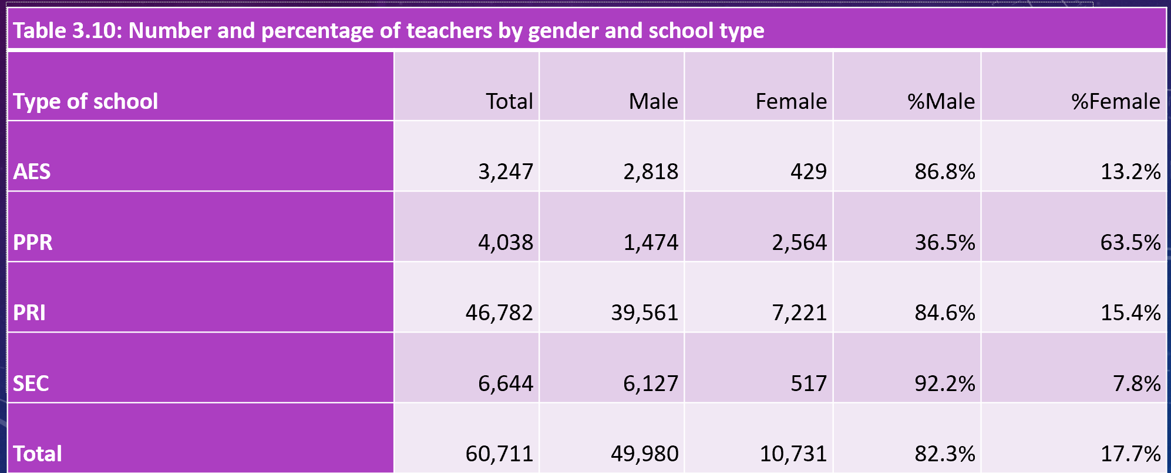
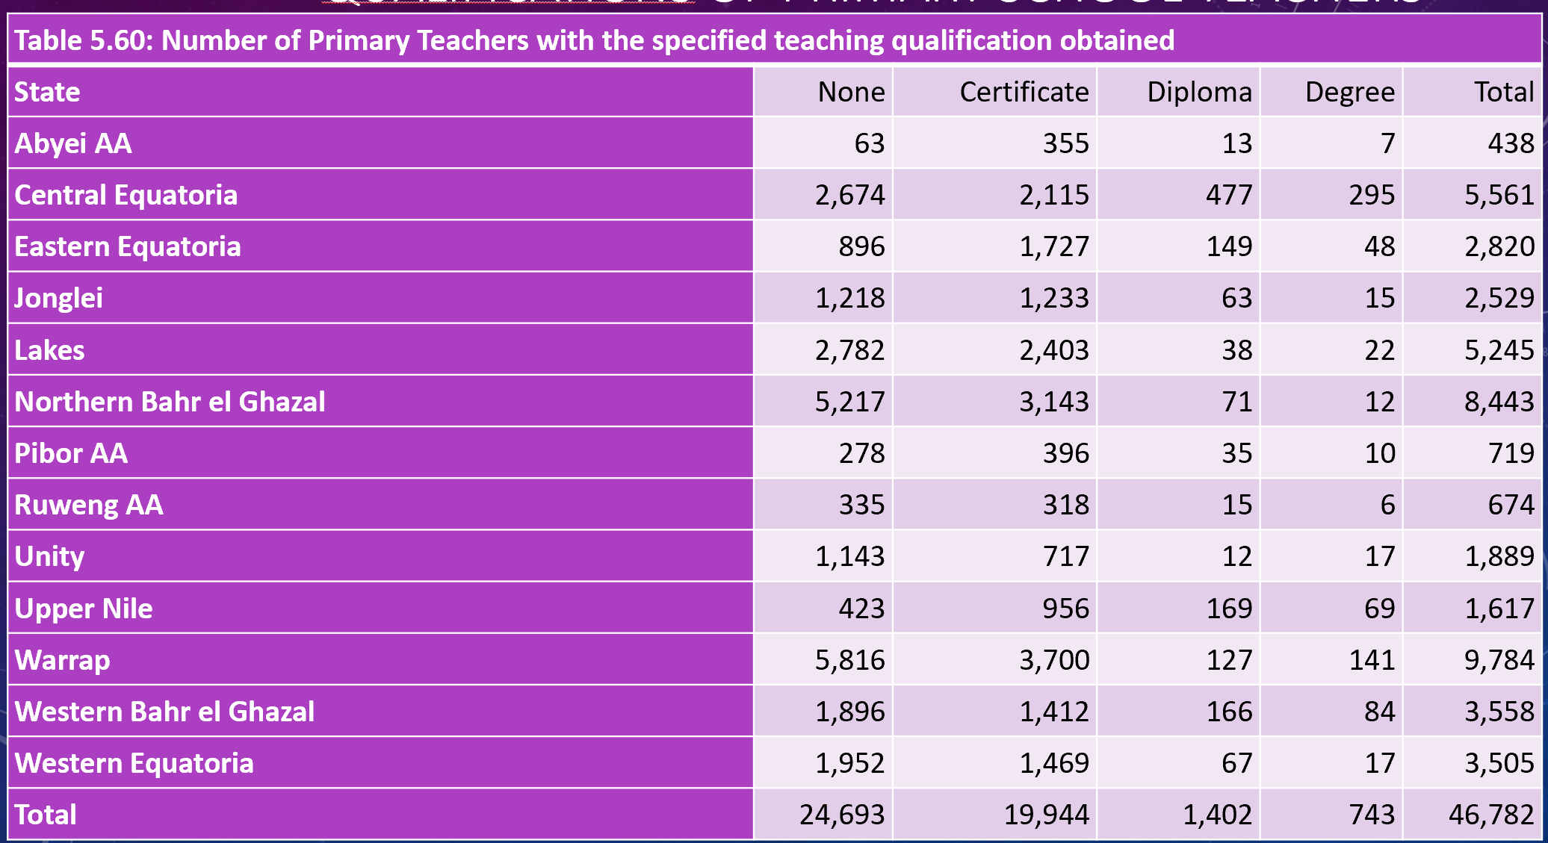
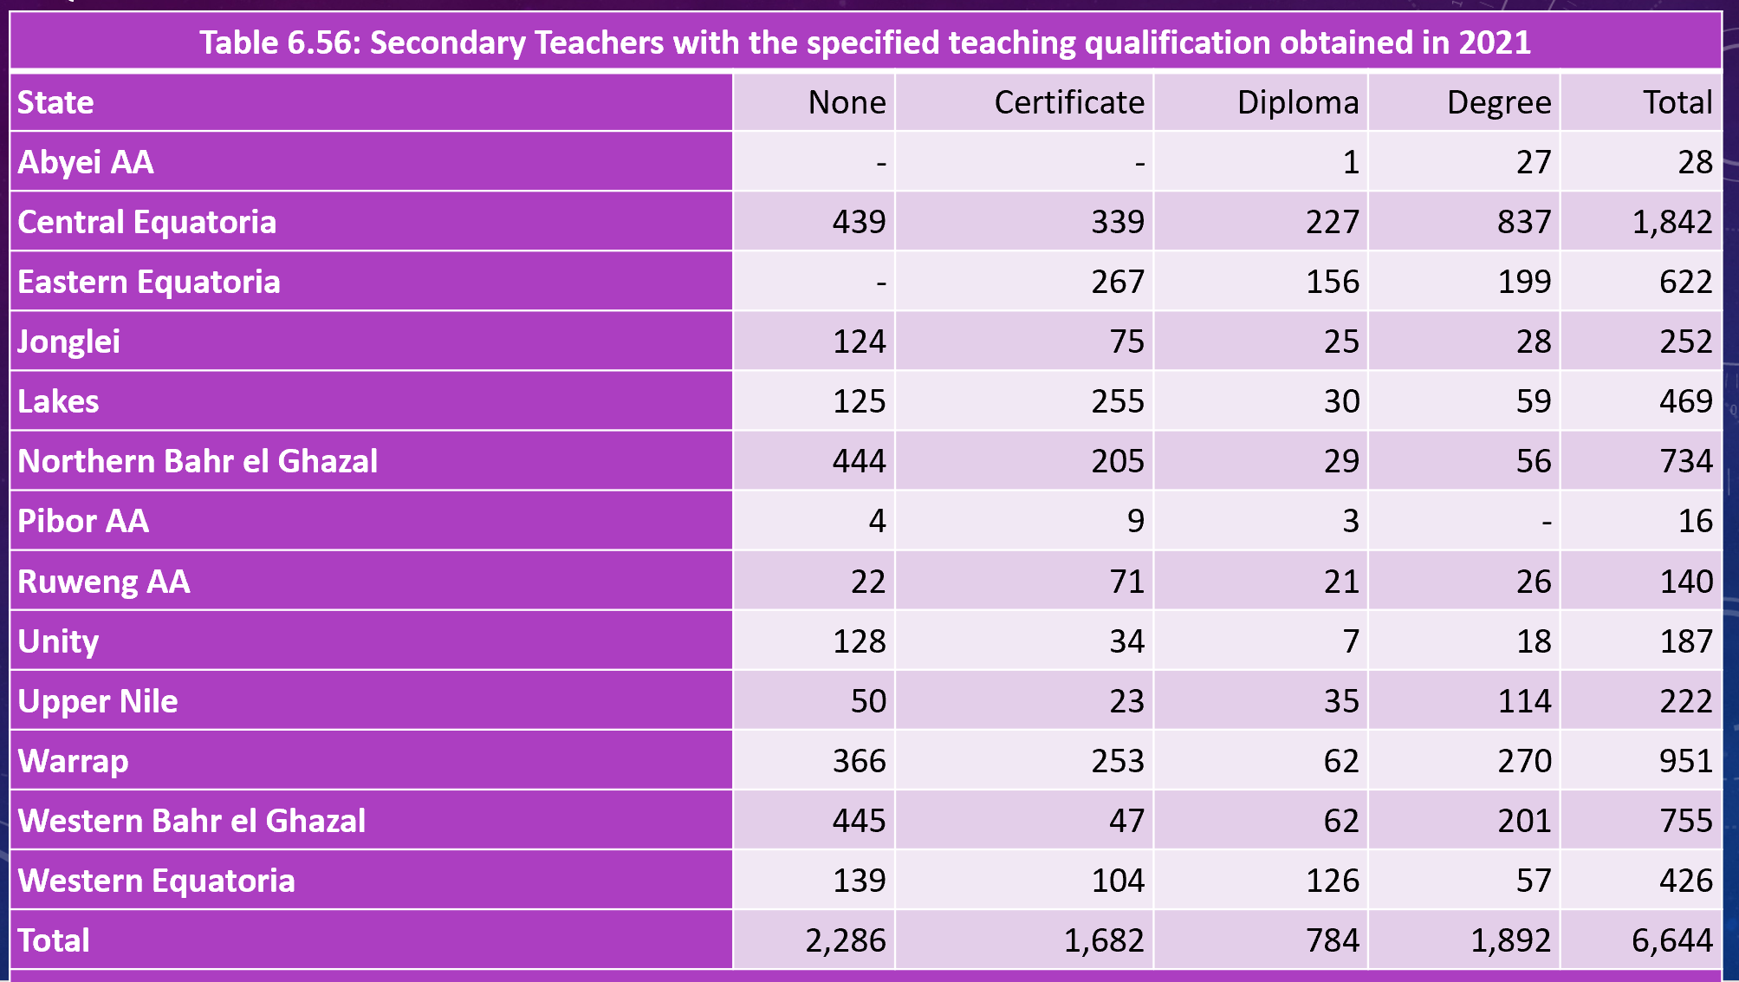
Appendix 5
Key references for the Literature Review
Abakah, E., Widin, J., & Ameyaw, E. K. (2022). Continuing Professional Development (CPD) Practices Among Basic School Teachers in the Central Region of Ghana. SAGE Open, 12(2). https://doi.org/10.1177/21582440221094597
Aelterman, N., Vansteenkiste, M., Van Keer, H., & Haerens, L., (2016) Changing teachers' beliefs regarding autonomy support and structure: The role of experienced psychological need satisfaction in teacher training, Psychology of Sport and Exercise, Vol 23, pp 64-72
Badroodien, A. (2018). Continuing professional teacher development in Sub-Saharan Africa: Improving teaching and learning. Bloomsbury Publishing.
Buhl-Wiggers, J., Kerwin, J., Smith, J., & Thornton, R. (2017). The Impact of Teacher Effectiveness on Student Learning in Africa. Rise Programme.
Hanushek, E. A., & Rivkin, S. G. (2010). Generalizations about using value-added measures of teacher quality. American economic review, 100(2), 267-71.
Evans, D. K., & Popova, A. (2016). What really works to improve learning in developing countries? An analysis of divergent findings in systematic reviews. The World Bank Research Observer, 31(2), 242-270.
Korthagen, F. (2017). Inconvenient truths about teacher learning: Towards professional development 3.0. Teachers and teaching, 23(4), 387-405.
Popova, A., Evans, D. K., Breeding, M. E., & Arancibia, V. (2018). Teacher professional development around the world: The gap between evidence and practice. The World Bank Policy Research Working Paper 8527
Tulu, A., (2019) The practice and challenges of school-based teachers’ continuous professional development: A case of Government Secondary Schools of Hawassa City in Ethiopia, Educational Research and Reviews, Vol.14(1) pp.33-43

The ILO/UNESCO Recommendation concerning the Status of Teachers (1966)
Transforming our world: the 2030 Agenda for Sustainable Development | Department of Economic and Social Affairs (un.org)
Literacy Rate by Country 2022 (worldpopulationreview.com)
(Source: SSD.pdf (undp.org))
Prfessional-Standards-for-Teacher-South-Sudan.pdf (curriculumfoundation.org)
Contextualized Out of School Children Catchment and Profile Mapping in South Sudan, 2021Report.
(Anti-corruption and the 5 pillars of sustainable development – UN SDG:Learn (unsdglearn.org)

